**https://localhost:7074/api/Patient/getpatientdetails**

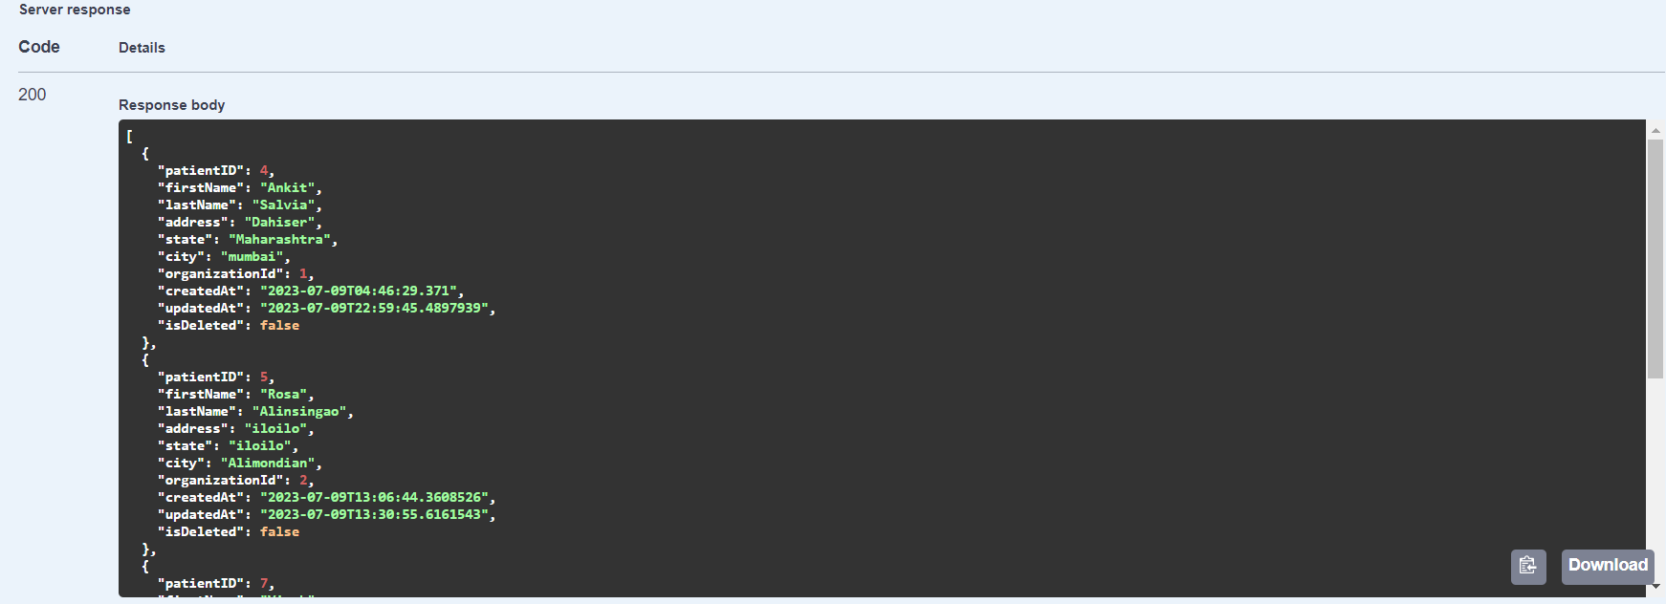

**https://localhost:7074/api/Patient/getpatientdetailbyid?patientID=4**

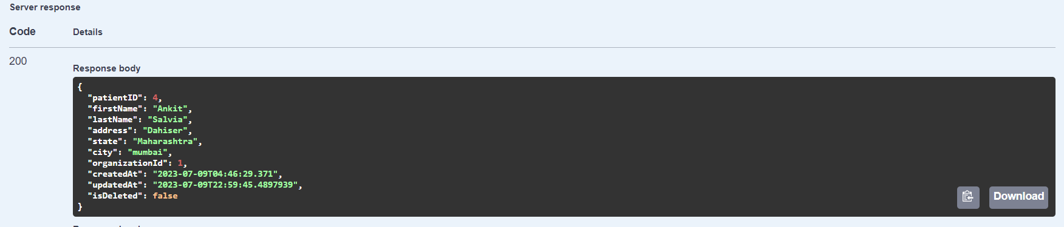

**https://localhost:7074/api/Patient/addpatientdetails**

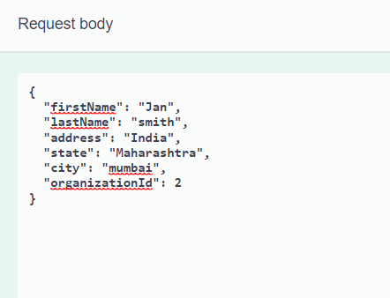

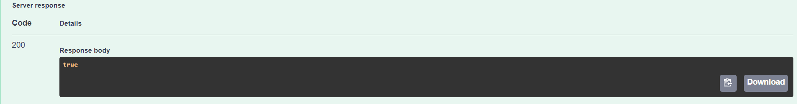

**https://localhost:7074/api/Patient/updatepatientdetails**

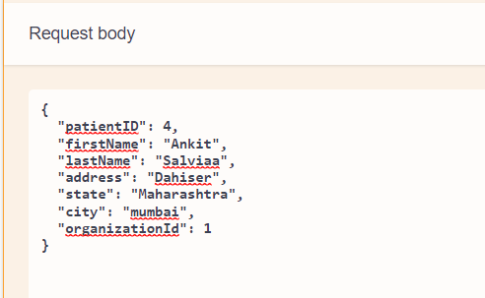

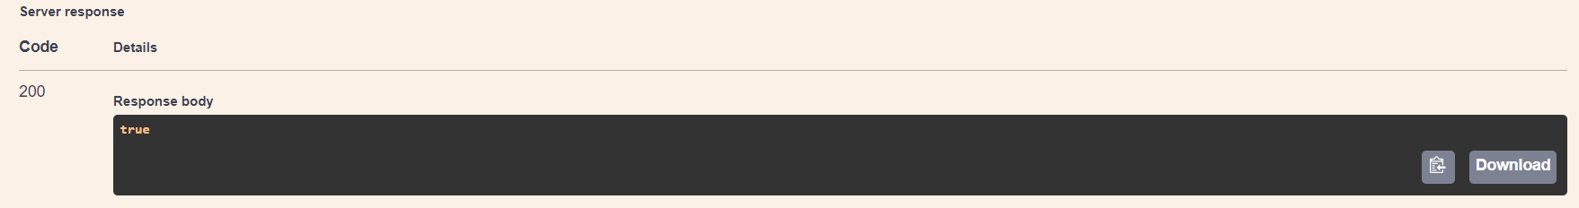

**https://localhost:7074/api/Patient/deletepatientdetails?patientID=10**

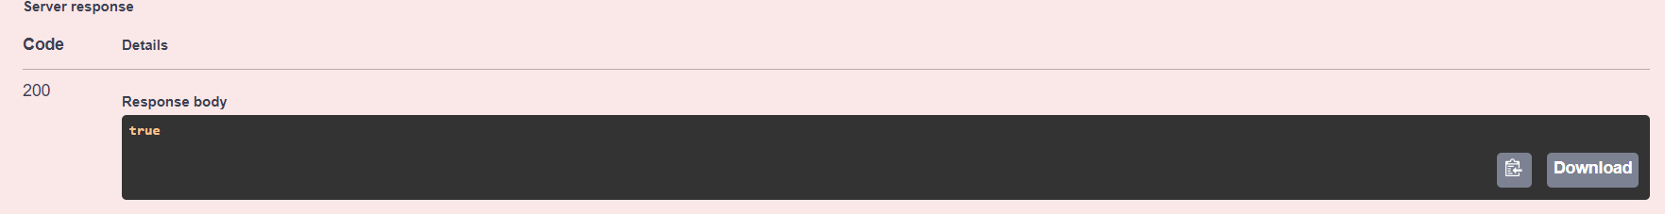

**https://localhost:7074/api/Visit/getallvisit**

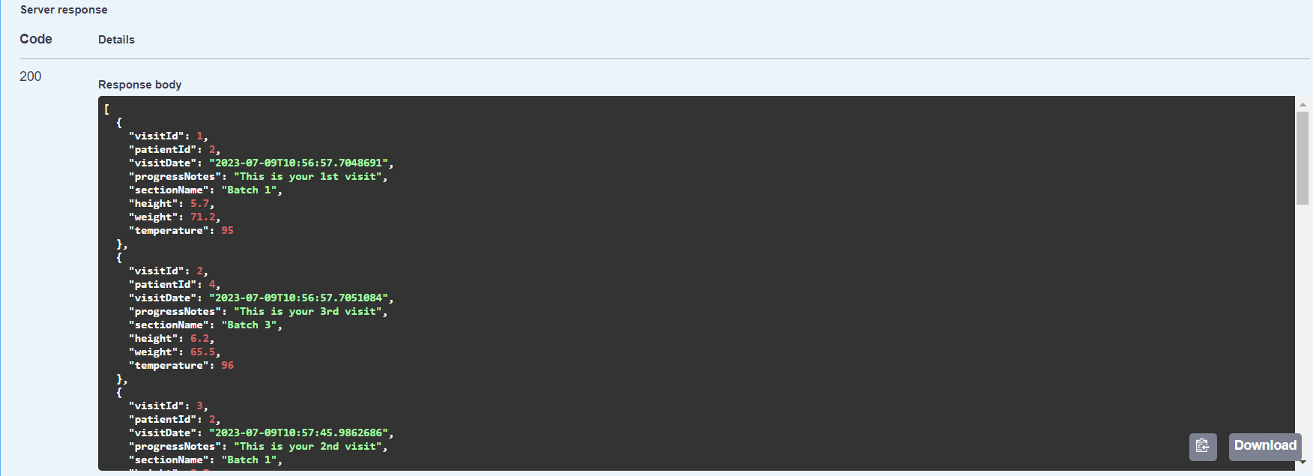

**https://localhost:7074/api/Visit/addallvisitdetails**

